A Technical Report

on

**SOLAR OPERATED LIGHT WITH CHARGING PORT**

*Submitted to CMR Institute of Technology in the partial fulfillment of the requirement of*

**Social Innovation Lab**

Of

**II B.Tech I- Semester**

in

**ECE DEPARTMENT**

Submitted by

**K.VAMSHIKRISHNA. (21R05A0407)**

**A.PRANITH. (21R05A0408)**

**L.PAVAN KUMAR (20R01A0487)**

**B.DILEEP (20R01A0465)**

**B.ABHIRAM (20R01A0463)**

***Under the esteemed guidance of***

*Mr.C.Ramakrishna*

*Assistant Professor*



**CMR INSTITUTE OF TECHNOLOGY**

**(UGC-AUTONOMOUS)**

(Approved by AICTE, Permanently Affiliated to JNTU Hyderabad, Accredited by NBA, Accredited by NAAC with A Grade)

Kandlakoya (V), Medchal Road, Hyderabad 501 401

2021-2022

***Department of ECE***

**Certificate**

This is to certify that the technical report entitled“SOLAR OPERATED LIGHT WITH CHARGING PORTS” is the bonafidework done and submitted by

K.VAMSHIKRISHNA. (21R05A0407)

A.PRANITH. (21R05A0408)

L.PAVANKUMAR. (20R01A0487)

B.DILEEP. (20R01A0465)

B.ABHIRAM. (20R01A0463)

towards the partial fulfillment of the requirement of Social Innovation (SIL) Laboratory of **II B. Tech I-Semester** in **ECE** is a record of bonafide work carried out by them during the period **September 2021 to January 2022.**

**Guide Co- Ordinator Head of Department**

***Mr.C.Rama krishna Mr. P.Nagaraj Dr.K.Niranjan Reddy***

***Assistant professor. Assistant professor. ECE Department***

***CSE Department CSE Department***

**INDEX**

**Topics Page No**

**CHAPTER-I INTRODUCTION 1**

**CHAPTER -II Empathize 4**

**CHAPTER -III Define** 5

**CHAPTER -IV Ideate 6**

**CHAPTER -V Prototype 7**

**CHAPTER -VI Test 9 CHAPTER -VII Reference 10**

**.**

**1.INTRODUCTION**

* **WHAT IS SOCIAL INNOVATION?**

The term ‘social innovation ’once rarely heard is ,now often used to describe a whole variety of things that fall into general categories of being both new and good.It’s understandable that the phrase has become popular-we get excited and hopeful when it seems possible for real change to happen in the world.

Social innovation refers to the Design and implementation of new solutions that imply conceptual ,process ,product or organisational change which ultimately aim to improve the welfare and wellbeing of individual communities

Social innovation is not a new concept and should not be considered similar to other definitions, such as social entrepreneurship, creativity or invention, improvement or change. 'As with innovation in technology or business, social innovation is distinct from ‘improvement’ or ‘change’ and from ‘creativity’ and ‘invention’. These last two are both crucial to innovation but overlook the important stages of implementation and diffusion which make new ideas useful.

* **What is design thinking process?**

Design Thinking is a design methodology that provides a solution-based approach to solving problems. It’s extremely useful in tackling complex problems that are ill-defined or unknown, by understanding the human needs involved, by re-framing the problem in human-centric ways, by creating many ideas in brainstorming sessions, and by adopting a hands-on approach in prototyping and testing. Understanding these five stages of Design Thinking will empower anyone to apply the Design Thinking methods in order to solve complex problems that occur around us — in our companies, in our countries, and even on the scale of our planet.

Design thinking originally came about as a way of teaching engineers how to approach problems creatively, like designers do. One of the first people to write about design thinking was John E. Arnold, professor of mechanical engineering at Stanford University.

**The five stages of design thinking:**

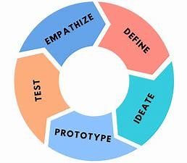

1. Empathize-The Design Thinking process starts with empathy. In order to create desirable products and services, you need to understand who your users are and what they need.
2. Define- In the second stage of the Design Thinking process, you’ll define the user problem that you want to solve.
3. Ideate.-The third stage in the Design Thinking process consists of ideation or generating ideas. ...
4. Prototype- In the fourth stage of the Design Thinking process, you’ll turn your ideas from stage three into prototypes.
5. Test -The fifth step in the Design Thinking process is dedicated to testing: putting your prototypes in front of real users and seeing how they get on.

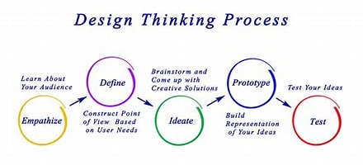

**2.Empathize**

The first stage of the Design Thinking process is to gain an empathic understanding of the problem you are trying to solve. This involves consulting experts to find out more about the area of concern through observing, engaging and empathizing with people to understand their experiences and motivations, as well as immersing yourself in the physical environment so you can gain a deeper personal understanding of the issues

involved. Empathy is crucial to a human-centered design process such as Design Thinking, and empathy allows design thinkers to set aside their own assumptions about the world in order to gain insight into users and their needs.

We have collected information from various sources like conducting surveys among the people about their problems as they are facing right now and interviewing people, reading novels from various books ,collecting information from the internet.

As our team has conducted a survey among the people at the current problems they are facing we have got many problems to be listed .In those information we have found many valid problems as they are facing in the day to day life and the collected information have been segregated accordingly.

We have shortlisted few problems which are being affected by the most people in the society .

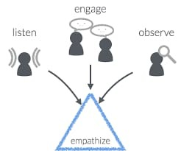

So , have chosen one of the problem that is the our project will helps the passangers and travellers to recharge their Electronic gadgets in emergency cases.

**3.Define**

In this define stage, we have defined the problem statement accordingly to our problem. According to the scenario as we have collected information in the empathy stage we have defined the problem statement as “SOLAR OPERATED LIGHT WITH CHARGING PORT”

**3.1. Problem Statement**

TO REDUCE MAN POWER AND HIGH CONSUMPTION OF ELECTRICITY

**3.2 Objective :-**

* To reduce high power consumption
* To reduce man power
* To charge electronic gadgets

**3.3 ADVANTAGES AND DISADVANTAGES OF EXISTING SOLUTIONS**

**ADVANTAGES:-**

* We can charge electronic gadgets
* We can operate street light automatically using LDR
* Works efficienctly
* Less expensive

**DISADVANTAGES:-**

* Some time it fails due to some power issues .

**­4.Ideate**

We gathered this idea by discussing with our teammates each of us explored different ideas on this project and data is collected under guidency of respective sir’s presented in our innovative lab.

**5.Prototype**

The next step is making a prototype , that is for making a prototype we require components like

**COMPONENTS REQUIREMENTS :-**

1) solar pannel.

2) battery.

3) Usb port .

4) ldr (light dependent resistor) .

5) led lights(light emiiting diode).

6) connecting wires.

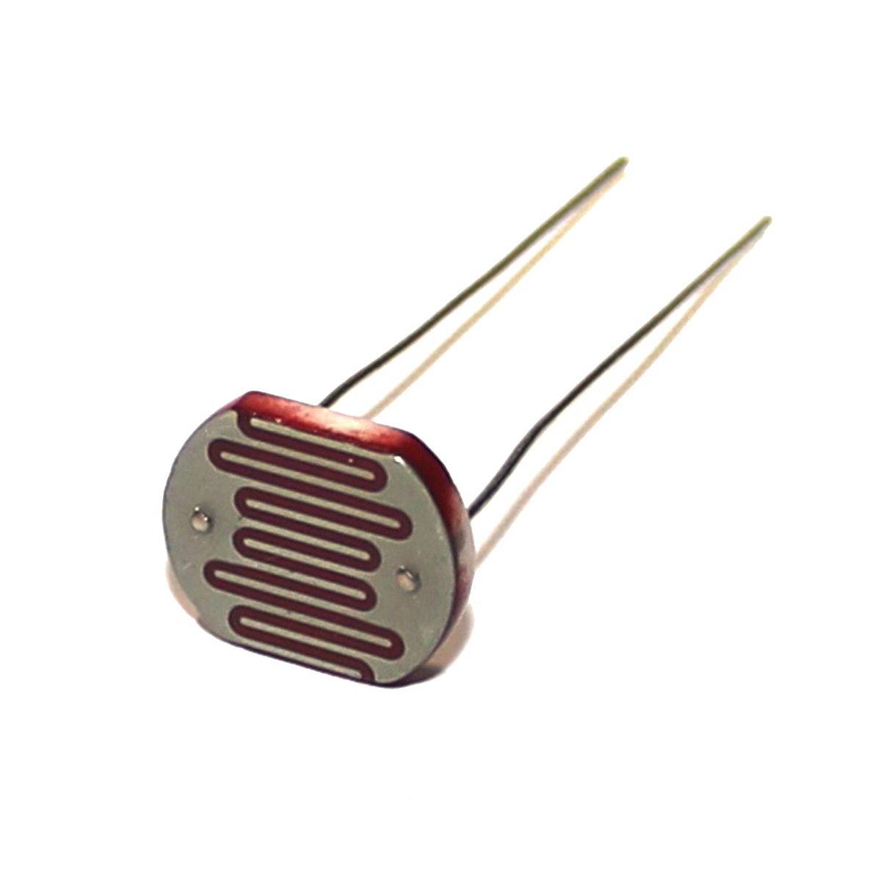

* A Light Dependent Resistor (also known as a photoresistor or LDR) is a device whose resistivity is a function of the incident electromagnetic radiation. Hence, they are light-sensitive devices.

Fig 3.1: Component 1

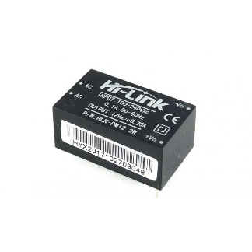

BATTERY

This Battery can be used for charging smartphones and to switch on the lights. Charge and the second is a DC-DC boost converter module.

Fig 3.2 : Component 2

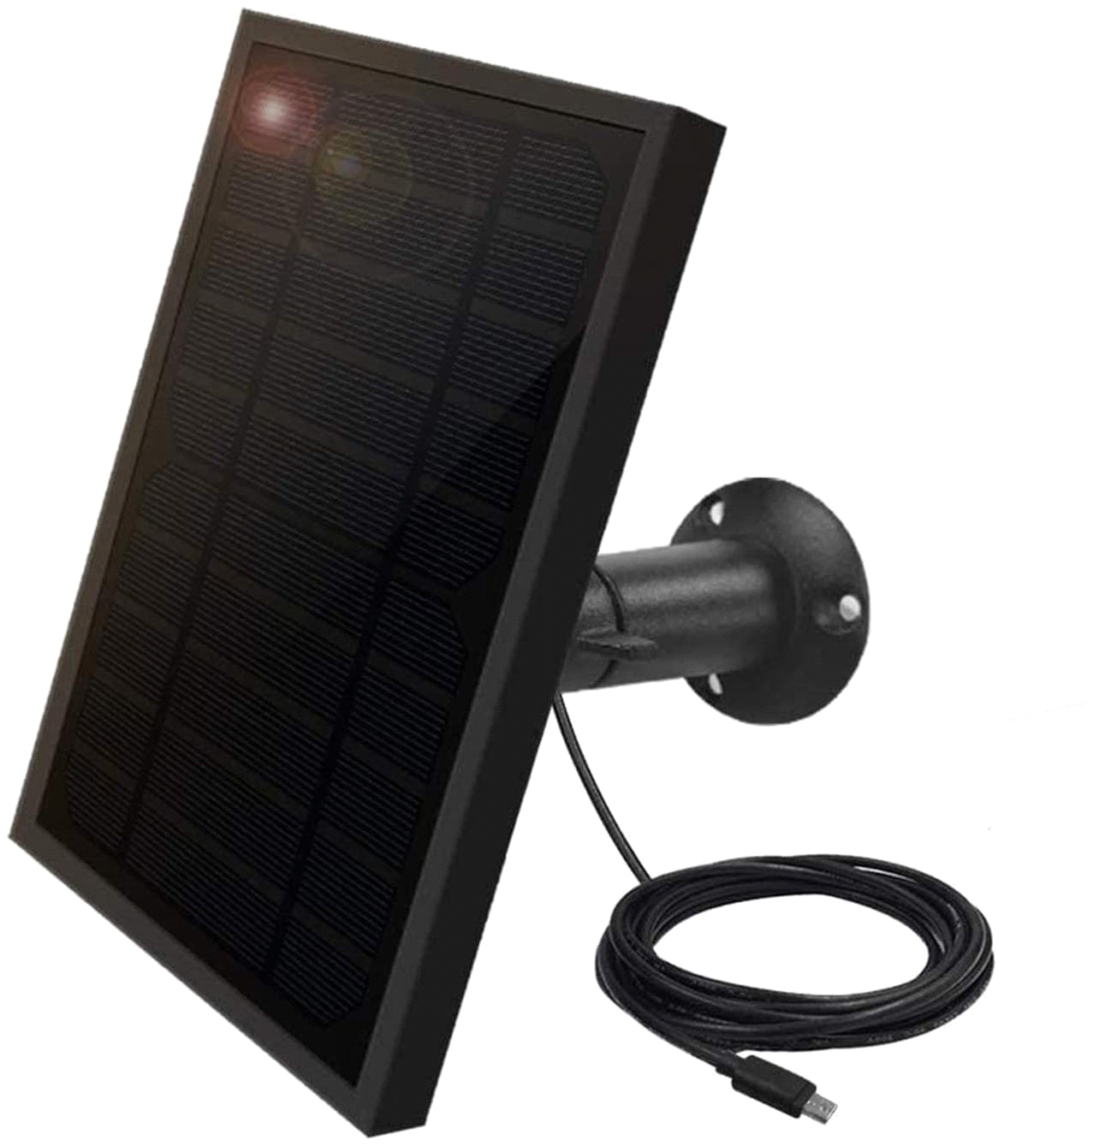

SOLAR PANEL

Solar energy begins with the sun. Solar panels (also known as " PV panels") are used to convert light from the sun, which is composed of particles of energy called " photons ", into electricity that can be used to power electrical loads.

Fig 3.3: Component 3

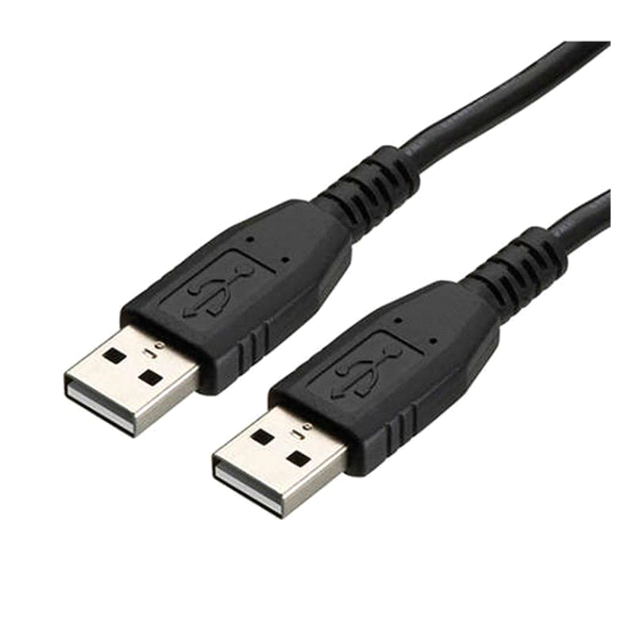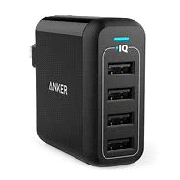

CHARGING PORTS / **cabels**

Universal Serial Bus (USB) is an industry standard that establishes specifications for cables, connectors and protocols for connection, communication and power supply (interfacing) between computers, peripherals and other computers.

Fig 3.4: Component 4

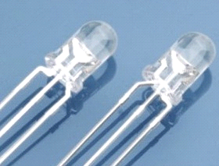  
  
LED[light emitting diode]

A light-emitting diode (LED) is a semiconductor device that emits light when an electric current flows through it.

Fig 3.5: Component 5

Fig 4 Prototype: _____________________

**6.test**

We have tested our project.With placing all the components properly.The sunlight which falls on the solar panel which emits the sunlight and it will charge the battery.

In the day time the solar energy is used to charge the Electronic gadgets.As well as the 12v batter will also charge.

The battery which is charged,will use to glow the lights in the night time and it will also use to charge the Electronic gadgets in night time at emergency purpose.

We have placed the LDR(light dependent resistor with lights to switch on the lights.At night time automatically.The LDR which helps to reduce the man power to switch on the lights automatically.

**REFERENCES:-**

*1) https://innovativeideasyoutube.blogspot.com/2021/08/automatic-solar-street-light-diagram.html*

*2) https://youtu.be/7Wyw7jbHURM*

*3) https://innovativeideasyoutube.blogspot.com/2021/08/automatic-solar-street-light-diagram.html*

*4) https://youtu.be/tQH2ugPcrL0*

*5) https://quartzcomponents.com/*